**Muhammad Abdullah**

**SE(4A) | 19F-0916**

Database Lab

DB LAB 11

**QUESTION # 01**

**NOTE: TRIGGERS ARE NOT INCLUDED BECAUSE IT WAS MEANT TO BE COVERED IN NEXT LAB**

**Part (a)**

**Part (b)**

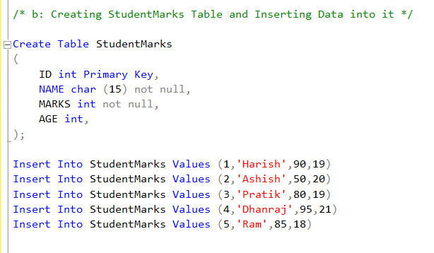

**Part (c and d)**

**Part (e and f)**

**Part (g and h)**

**Part (i)**

**Part (j)**

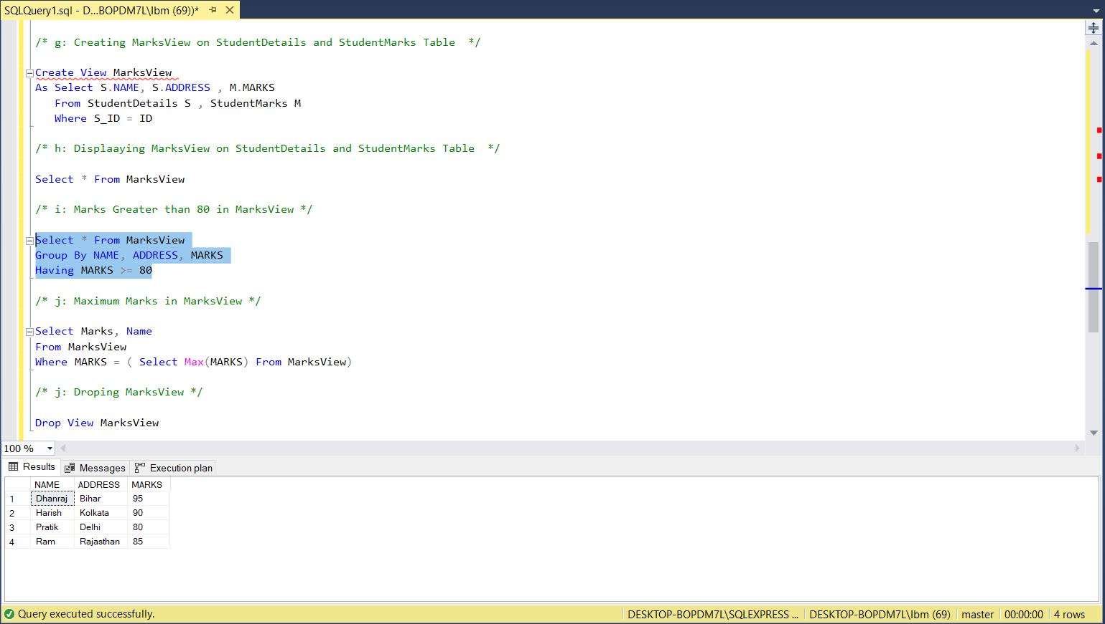

**Part (k)**

**QUESTION # 02**

**Part (a)**

**Part (b and result)**

**Part ( c and result)**

**QUESTION # 03**

